**Assignment: Final Project**

**Final_Project 25**

Hitaxi Jayantilal Kachhadiya

Alay BrijeshKumar Patel

MS in Information Technology, Arizona State University

IFT 530: Enterprise Data Management Systems

May 2nd , 2025

* **The script should create a new database with your <Group Name> for the assignment.**

CREATE DATABASE Final_Project_25_AirlineManagementDB

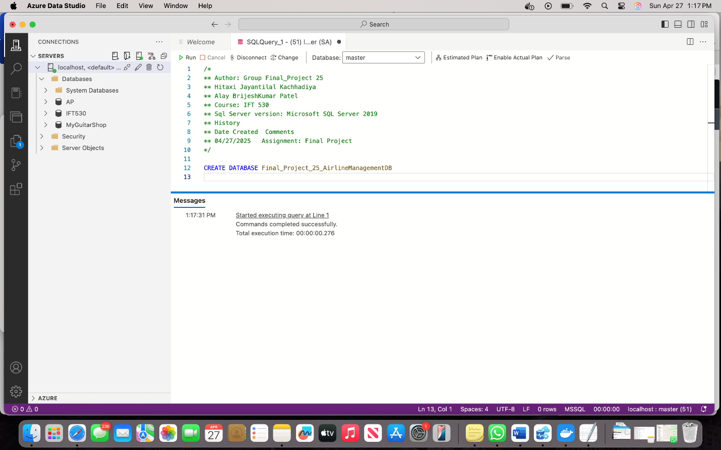

* **Create the tables using SQL script you have defined in the Final project**

Creating tables Airlines, Airport, Status, Terminal, Gate, Flights, Passenger, Booking, Cancellation and Staff.

-- 1. Airlines (Base Table)

CREATE TABLE Airlines (

AirlineId VARCHAR(100) NOT NULL PRIMARY KEY,

Name VARCHAR(100) NOT NULL UNIQUE,

Country VARCHAR(100) NOT NULL

);

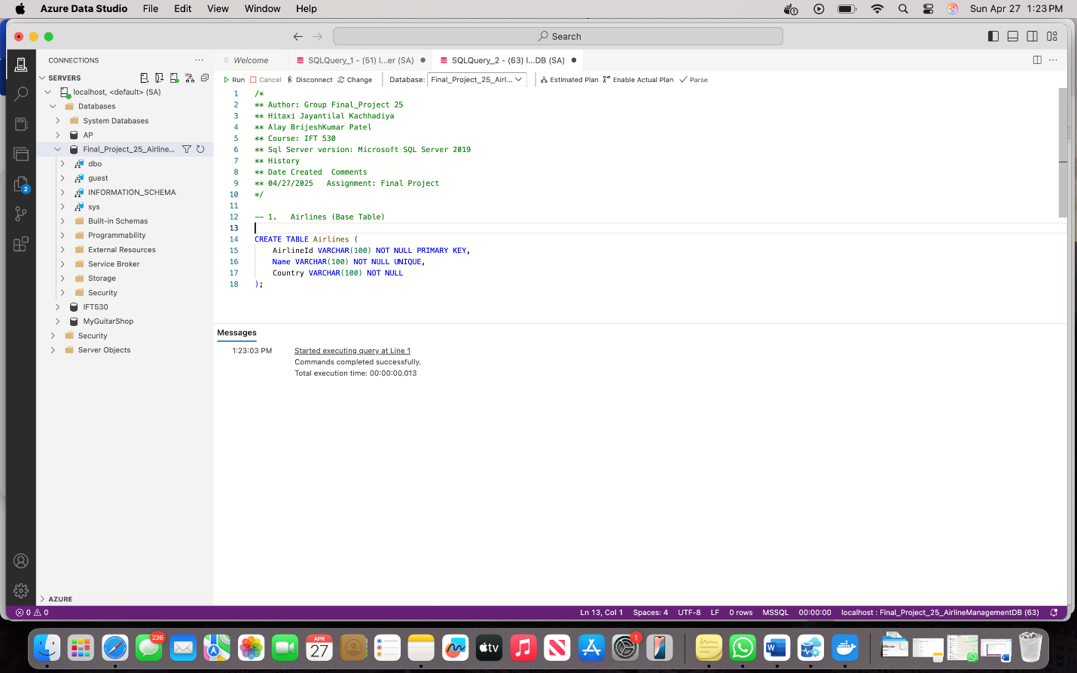

-- 2. Airport (Base Table)

CREATE TABLE Airport (

AirportId INT NOT NULL PRIMARY KEY,

AirportName VARCHAR(100) NOT NULL,

City VARCHAR(50) NOT NULL,

State VARCHAR(50) NULL,

Country VARCHAR(50) NOT NULL

);

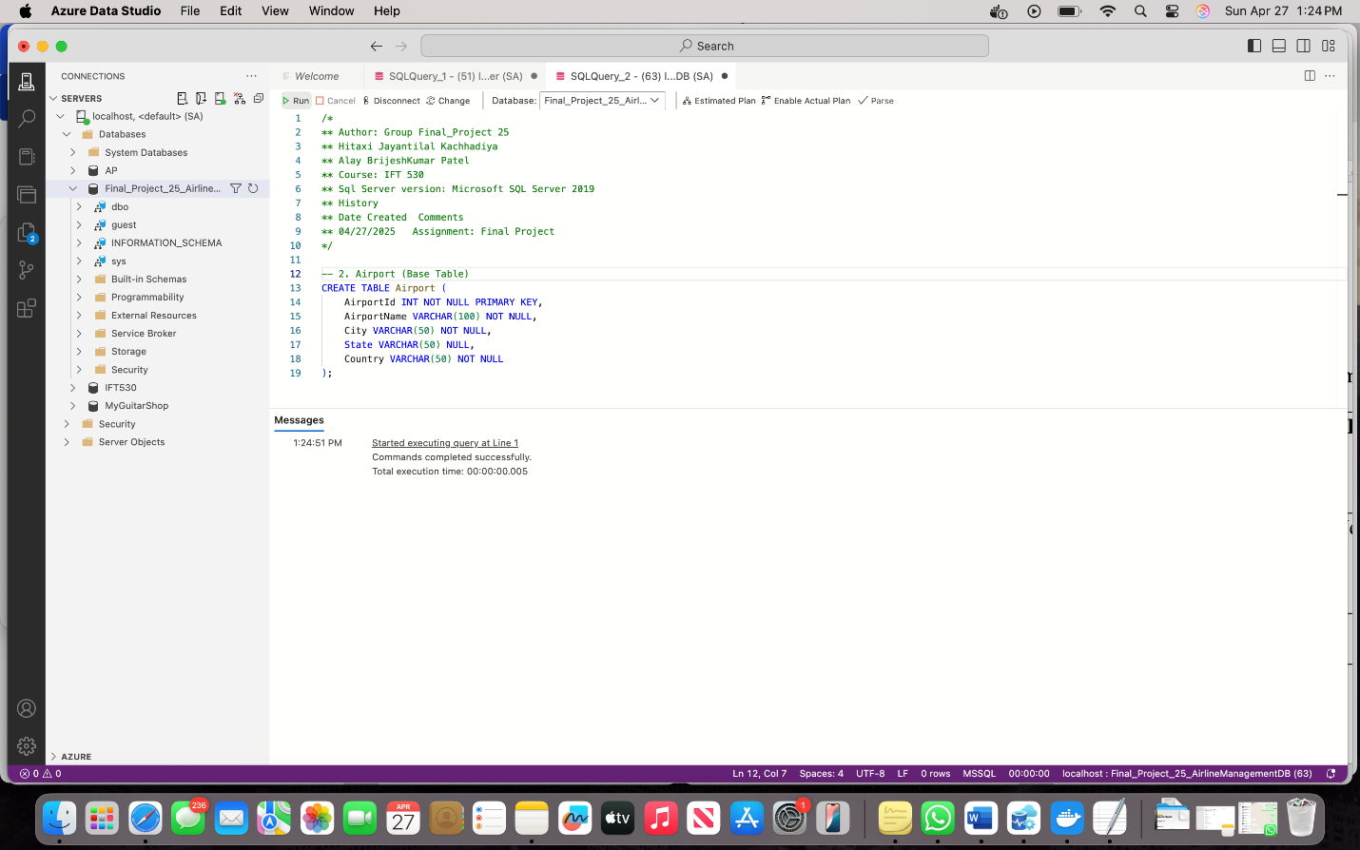

-- 3. Status (Base Table)

CREATE TABLE Status (

StatusID INT NOT NULL PRIMARY KEY,

StatusName VARCHAR(30) NOT NULL UNIQUE

);

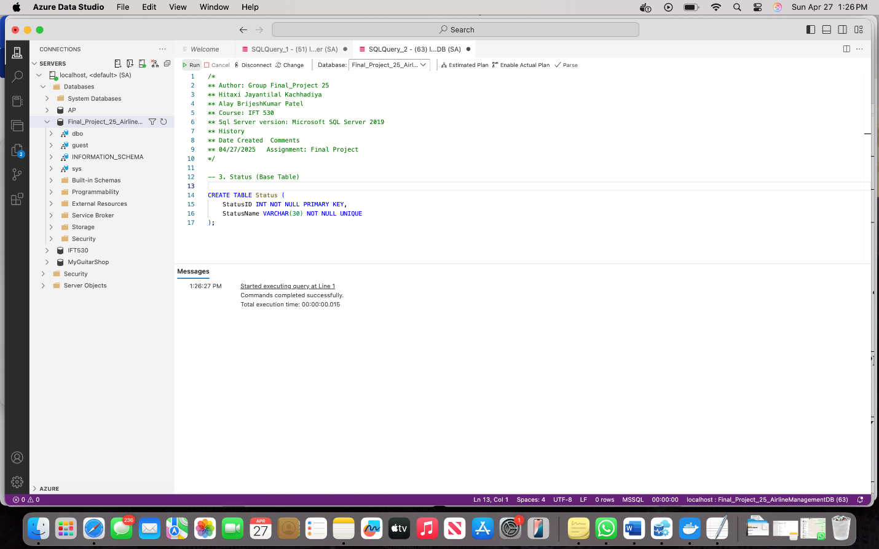

-- 4. Terminal (Base Table)

CREATE TABLE Terminal (

TerminalID INT NOT NULL PRIMARY KEY,

Name VARCHAR(20) NOT NULL UNIQUE,

AirportID INT NOT NULL,

FOREIGN KEY (AirportID) REFERENCES Airport(AirportId)

);

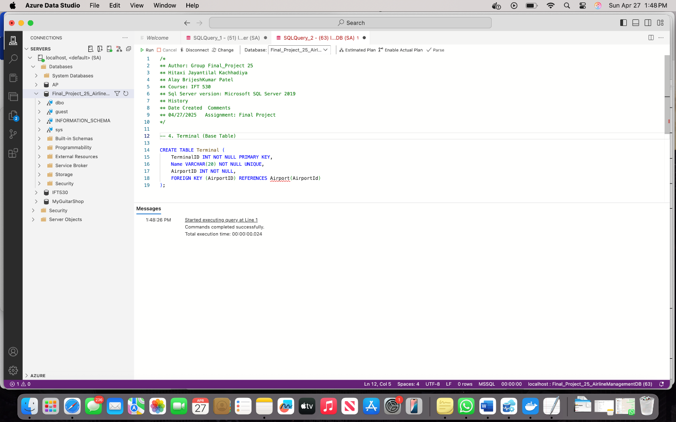

-- 5. Gate (Base Table)

CREATE TABLE Gates (

GateID INT NOT NULL PRIMARY KEY,

TerminalID INT NOT NULL,

GateNumber VARCHAR(10) NOT NULL,

FOREIGN KEY (TerminalID) REFERENCES Terminal(TerminalID)

);

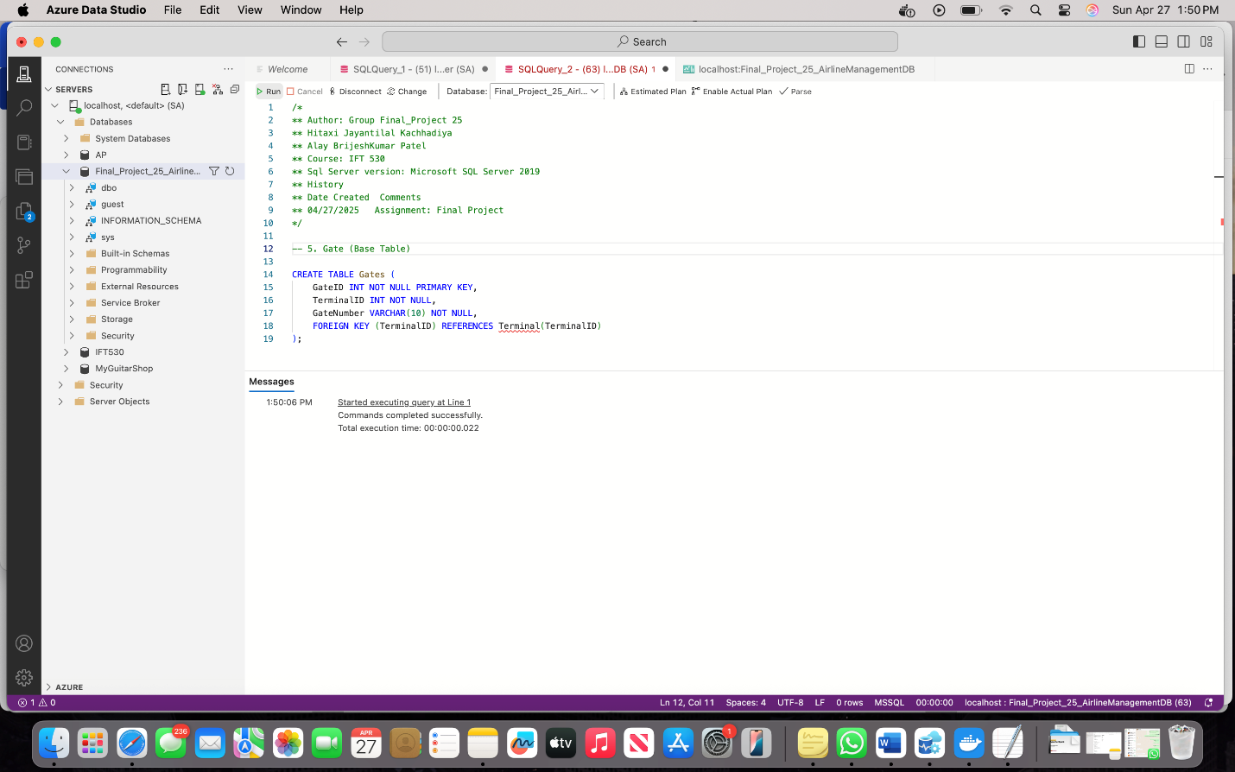

-- 6. Flights (Transaction Table)

CREATE TABLE Flights (

FlightID INT NOT NULL PRIMARY KEY,

AirlineId VARCHAR(100) NOT NULL,

DepartureTime DATETIME NOT NULL,

ArrivalTime DATETIME NOT NULL,

FromGateID INT NOT NULL,

ToGatetID INT NOT NULL,

StatusID INT NOT NULL,

FOREIGN KEY (AirlineId) REFERENCES Airlines(AirlineId),

FOREIGN KEY (FromGateID) REFERENCES Gates(GateId),

FOREIGN KEY (ToGatetID) REFERENCES Gates(GateId),

FOREIGN KEY (StatusID) REFERENCES Status(StatusID)

);

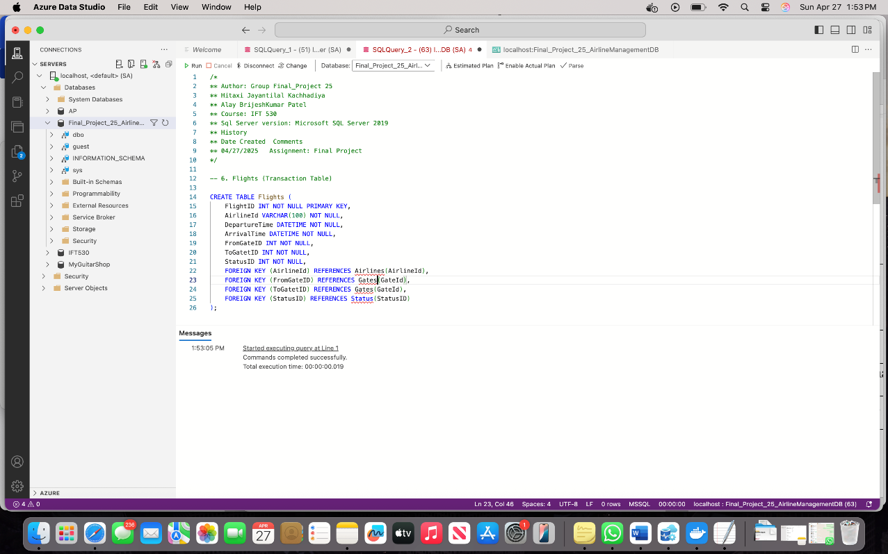

-- 7. Passanger (Base Table)

CREATE TABLE Passenger (

PassportNumber VARCHAR(10) NOT NULL PRIMARY KEY,

FirstName VARCHAR(50) NOT NULL,

LastName VARCHAR(50) NOT NULL,

Email VARCHAR(100) NOT NULL UNIQUE,

Phone VARCHAR(15) NULL

);

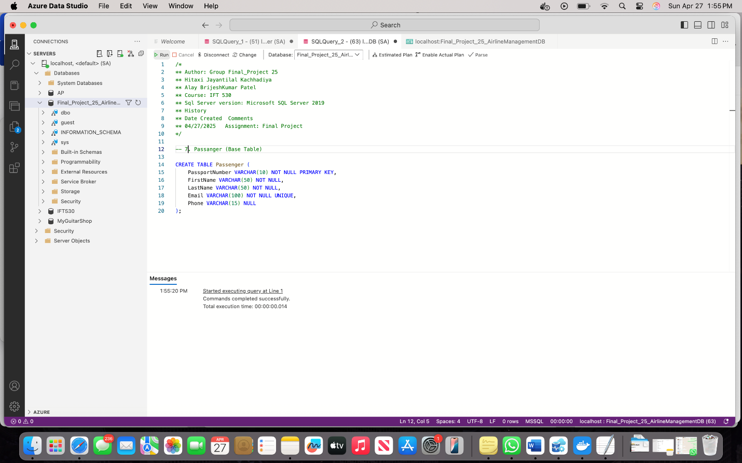

-- 8. Booking (Transaction Table)

CREATE TABLE Booking (

BookingID INT NOT NULL PRIMARY KEY,

PassportNumber VARCHAR(10) NOT NULL,

FlightID INT NOT NULL,

SeatNumber VARCHAR(3) NOT NULL,

BookingDate DATETIME NOT NULL,

FOREIGN KEY (PassportNumber) REFERENCES Passenger(PassportNumber),

FOREIGN KEY (FlightID) REFERENCES Flights(FlightID)

);

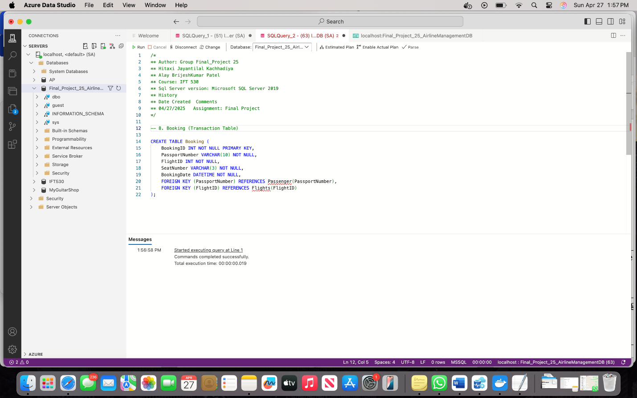

-- 9. Cancellation (Transaction Table)

CREATE TABLE Cancellation (

CancellationID INT NOT NULL PRIMARY KEY,

BookingID INT NOT NULL,

CancelledBy VARCHAR(20) NOT NULL,

CancellationDate DATE NOT NULL,

FOREIGN KEY (BookingID) REFERENCES Booking(BookingID)

);

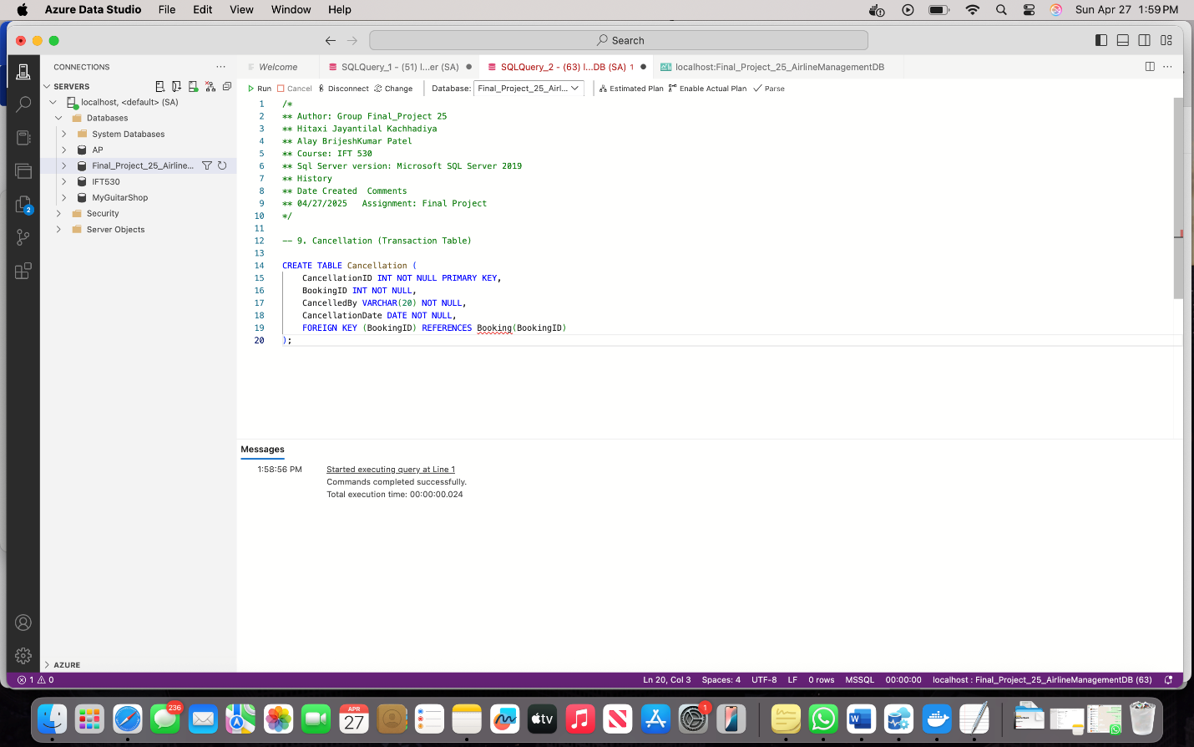

-- 10. Staff (Base Table)

CREATE TABLE Staff (

StaffID INT NOT NULL PRIMARY KEY,

Name VARCHAR(100) NOT NULL,

Role VARCHAR(50) NOT NULL,

FlightID INT NULL,

FOREIGN KEY (FlightID) REFERENCES Flights(FlightID)

);

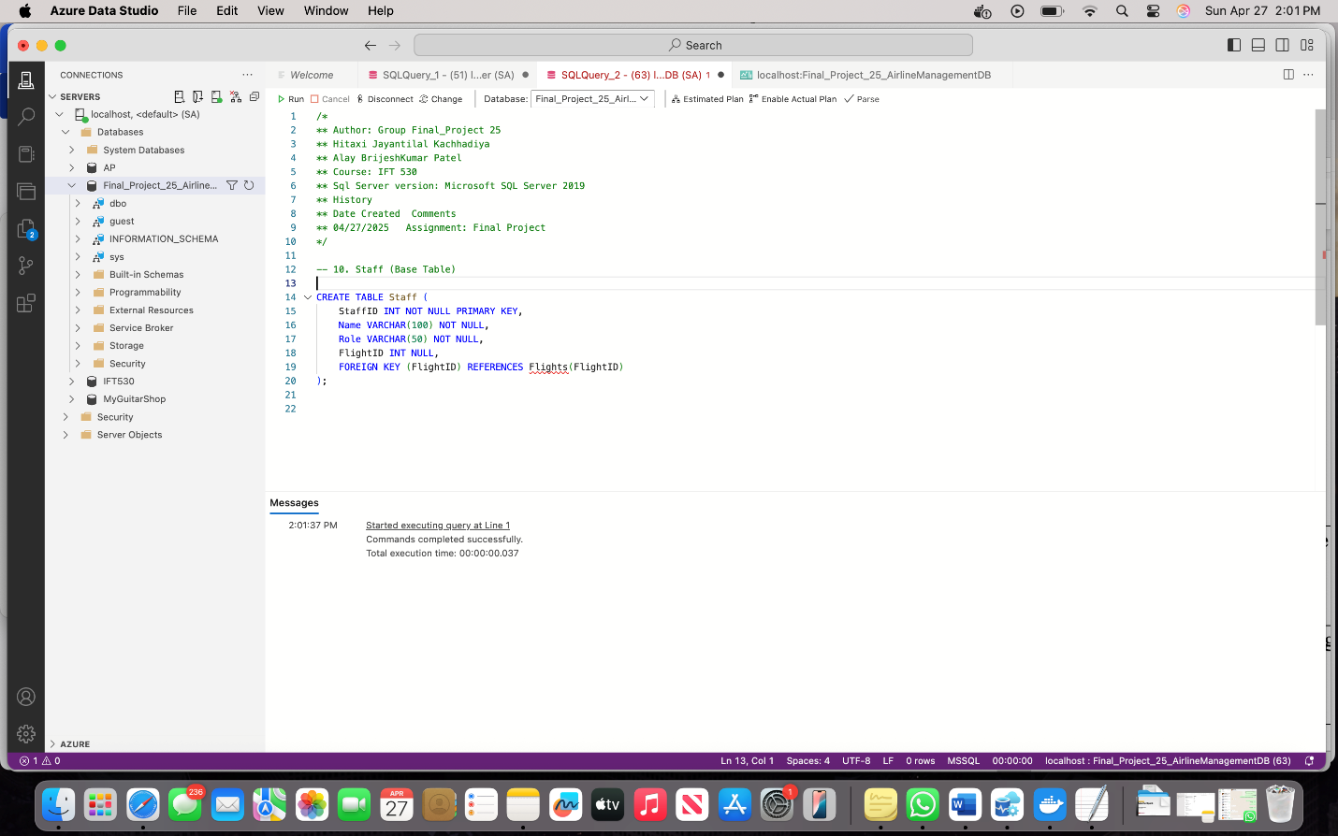

* **Generate the ERD diagram and paste it in a word document.**

An ERD was created to show the structure and relationships among tables in the Airline Management database. The ERD includes entities such as Airlines, Flights, Gates, Terminals, Passengers, and Bookings, with foreign key relationships clearly defined.

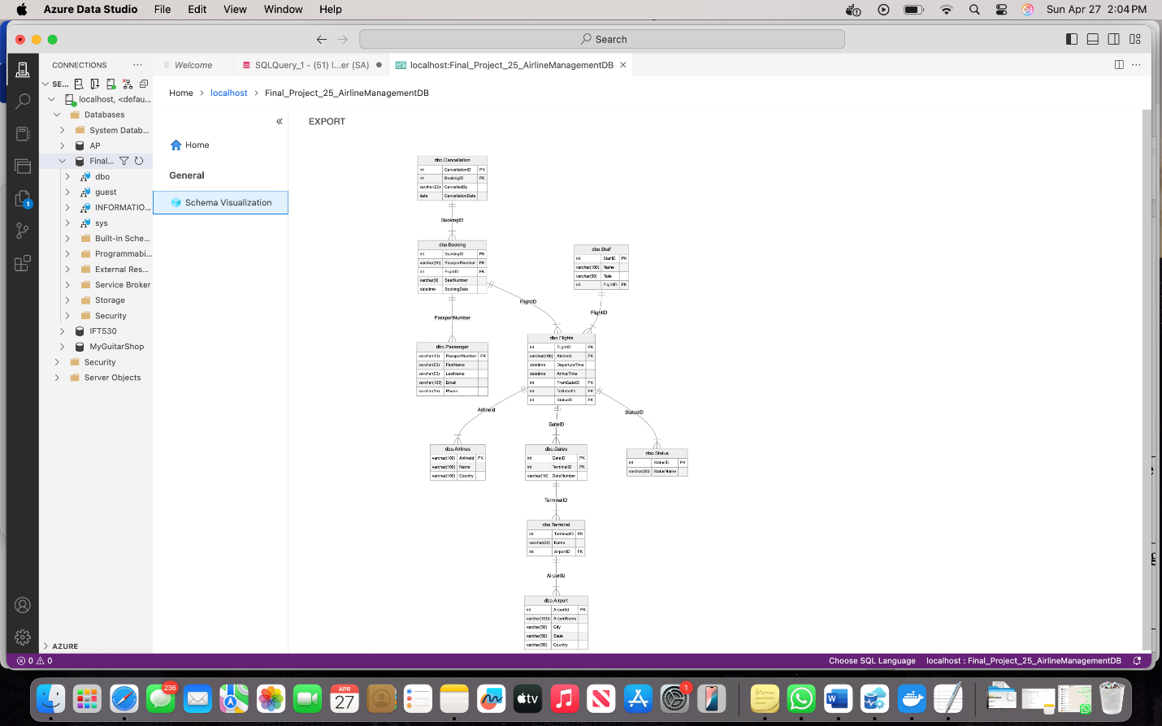

* **Populate the table with 10 rows for dimension tables, 20 – 50 rows for transactional  
  tables.**

We added sample data to each table. There are 10 rows in each basic table and 20 rows in each main activity table like Bookings. This data helps test the system and make sure everything works.

-- 1. Airlines

INSERT INTO Airlines (AirlineId, Name, Country) VALUES

('A001', 'Emirates', 'Saudi Arabia'),

('A002', 'Qatar Airlines', 'Qatar'),

('A003', 'Air India', 'India'),

('A004', 'American Airlines', 'USA'),

('A005', 'Japan Airlines', 'Japan'),

('A006', 'BlueJet', 'USA'),

('A007', 'Everest Air', 'Nepal'),

('A008', 'Pacific Breeze', 'Australia'),

('A009', 'British Airlines', 'UK'),

('A010', 'DragonFly', 'China');

Select * from Airlines

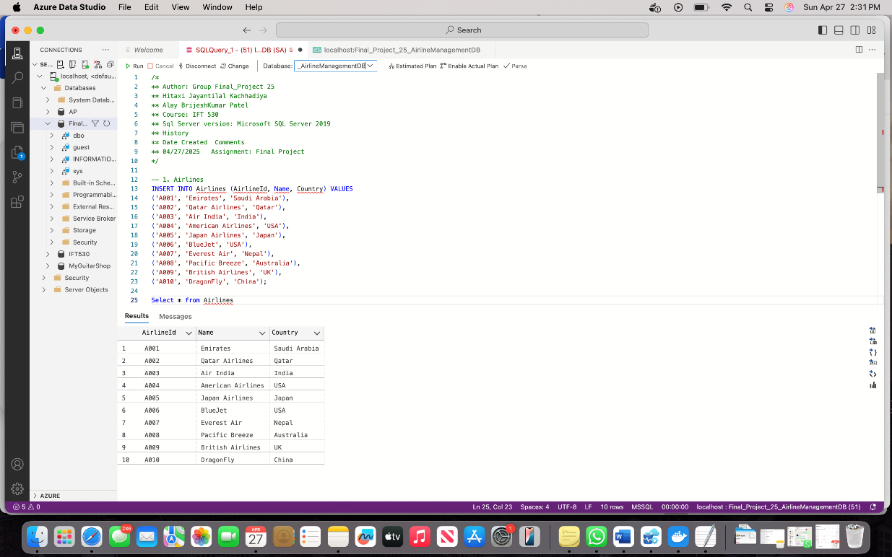

-- 2. Airport

INSERT INTO Airport (AirportId, AirportName, City, State, Country) VALUES

(1, 'JFK International', 'New York', 'NY', 'USA'),

(2, 'Doha Airport', 'Doha', NULL, 'Qatar'),

(3, 'Indira Gandhi Airport', 'Delhi', NULL, 'India'),

(4, 'Dubai International', 'Dubai', 'Dubai', 'Saudi Arabia'),

(5, 'Tokyo International', 'Tokyo', 'Tokyo', 'Japan'),

(6, 'LAX Airport', 'Los Angeles', 'CA', 'USA'),

(7, 'Sydney Airport', 'Sydney', 'NSW', 'Australia'),

(8, 'Kathmandu Airport', 'Kathmandu', NULL, 'Nepal'),

(9, 'Beijing Capital', 'Beijing', NULL, 'China'),

(10, 'Manchester Airport', 'Manchester', NULL, 'UK');

Select * from Airport

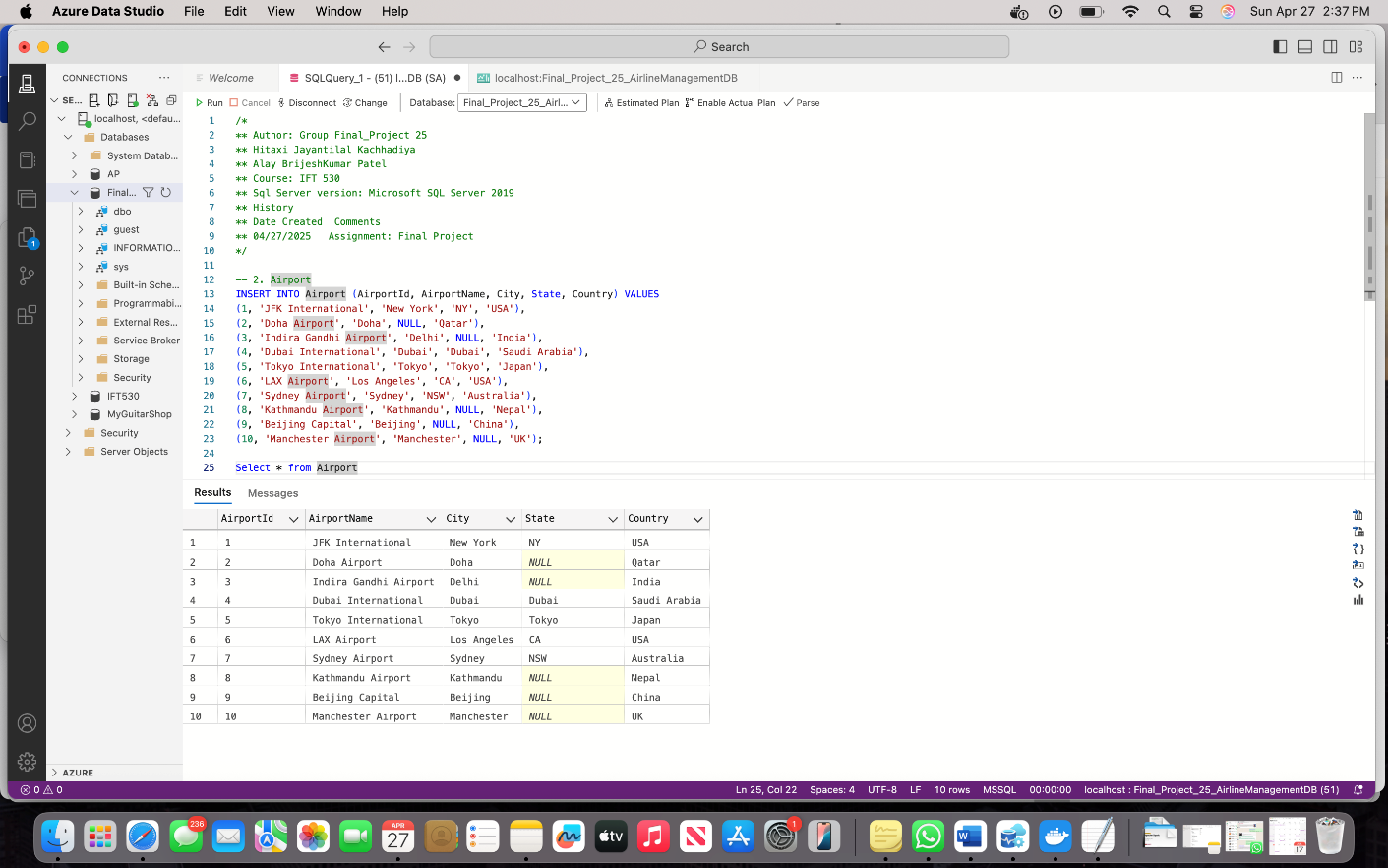

-- 3. Status

INSERT INTO Status (StatusID, StatusName) VALUES

(1, 'Scheduled'),

(2, 'Delayed'),

(3, 'Cancelled'),

(4, 'Departed'),

(5, 'Arrived'),

(6, 'Boarding'),

(7, 'Gate Change'),

(8, 'Security Check'),

(9, 'Last Call'),

(10, 'Closed');

Select * from Status

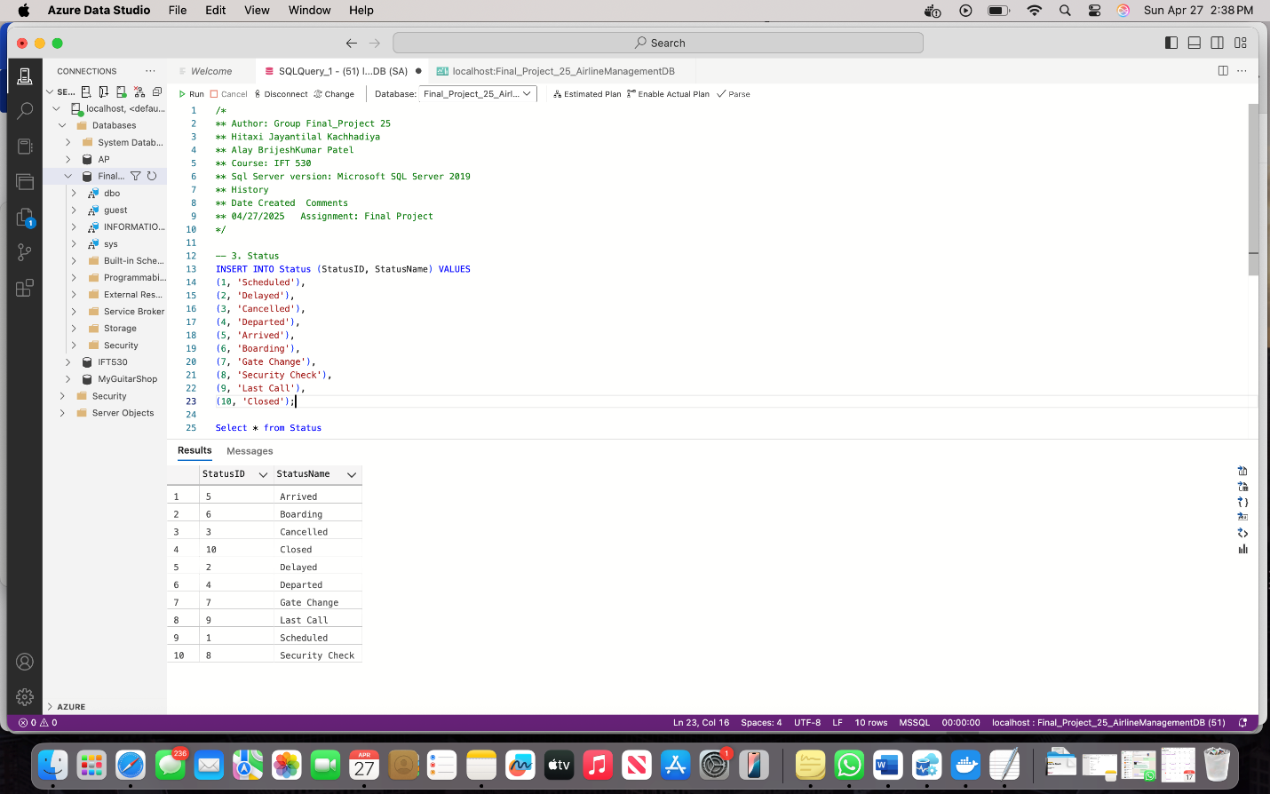

-- 4. Terminal

INSERT INTO Terminal (TerminalID, Name, AirportID) VALUES

(1, 'T1', 1),

(2, 'T2', 1),

(3, 'A', 2),

(4, 'B', 2),

(5, 'T3', 3),

(6, 'T4', 3),

(7, 'T5', 4),

(8, 'T6', 4),

(9, 'Main', 5),

(10, 'North', 6),

(11, 'South', 7),

(12, 'West', 8),

(13, 'East', 9),

(14, 'T7', 10);

Select * from Terminal

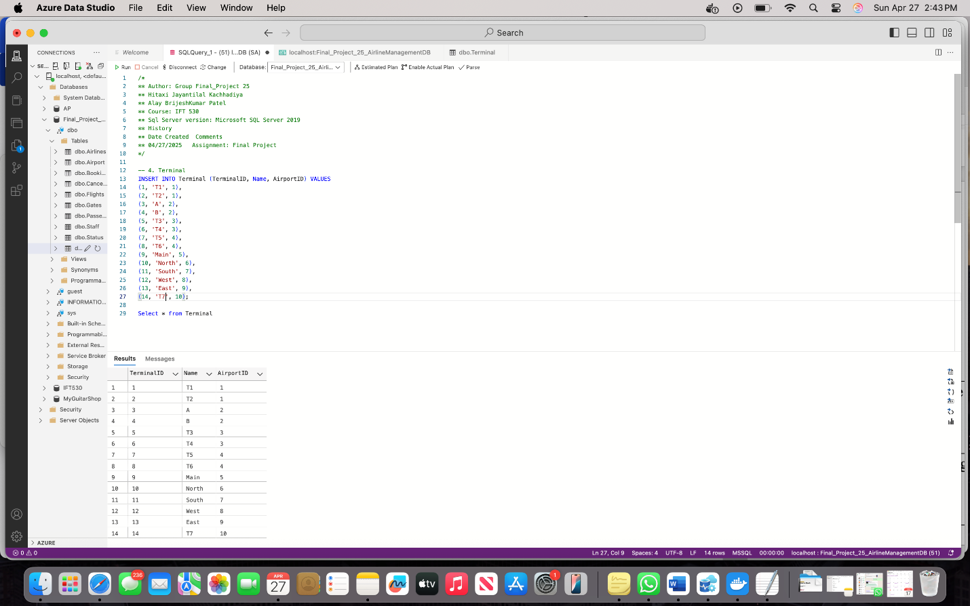

-- 5. Gates

INSERT INTO Gates (GateID, TerminalID, GateNumber) VALUES

(1, 1, 'G1'),

(2, 1, 'G2'),

(3, 2, 'G3'),

(4, 3, 'G4'),

(5, 4, 'G5'),

(6, 5, 'G6'),

(7, 6, 'G7'),

(8, 7, 'G8'),

(9, 8, 'G9'),

(10, 9, 'G10'),

(11, 10, 'G11');

Select * from Gates

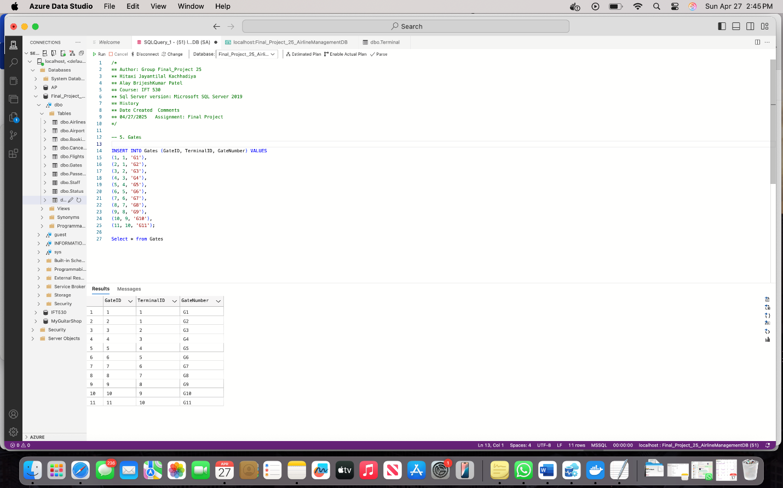

-- 6. Flights

INSERT INTO Flights (FlightID, AirlineId, DepartureTime, ArrivalTime, FromGateID, ToGatetID, StatusID) VALUES

(1, 'A001', '2025-05-01 08:00:00', '2025-05-01 12:00:00', 1, 4, 1),

(2, 'A002', '2025-05-01 09:30:00', '2025-05-01 13:30:00', 2, 5, 2),

(3, 'A003', '2025-05-02 10:00:00', '2025-05-02 14:00:00', 3, 6, 3),

(4, 'A004', '2025-05-02 11:00:00', '2025-05-02 15:00:00', 4, 7, 4),

(5, 'A005', '2025-05-03 07:00:00', '2025-05-03 11:00:00', 5, 8, 5),

(6, 'A006', '2025-05-03 08:30:00', '2025-05-03 12:30:00', 6, 9, 1),

(7, 'A007', '2025-05-04 06:00:00', '2025-05-04 10:00:00', 7, 10, 1),

(8, 'A008', '2025-05-04 13:00:00', '2025-05-04 17:00:00', 8, 1, 2),

(9, 'A009', '2025-05-05 09:00:00', '2025-05-05 13:00:00', 9, 2, 4),

(10, 'A010', '2025-05-05 15:00:00', '2025-05-05 19:00:00', 10, 3, 5),

(11, 'A001', '2025-05-06 08:00:00', '2025-05-06 12:00:00', 1, 4, 1),

(12, 'A002', '2025-05-06 09:30:00', '2025-05-06 13:30:00', 2, 5, 2),

(13, 'A003', '2025-05-07 10:00:00', '2025-05-07 14:00:00', 3, 6, 3),

(14, 'A004', '2025-05-07 11:00:00', '2025-05-07 15:00:00', 4, 7, 4),

(15, 'A005', '2025-05-08 07:00:00', '2025-05-08 11:00:00', 5, 8, 5),

(16, 'A006', '2025-05-08 08:30:00', '2025-05-08 12:30:00', 6, 9, 1),

(17, 'A007', '2025-05-09 06:00:00', '2025-05-09 10:00:00', 7, 10, 1),

(18, 'A008', '2025-05-09 13:00:00', '2025-05-09 17:00:00', 8, 1, 2),

(19, 'A009', '2025-05-10 09:00:00', '2025-05-10 13:00:00', 9, 2, 4),

(20, 'A010', '2025-05-10 15:00:00', '2025-05-10 19:00:00', 10, 3, 5);

Select * from Flights

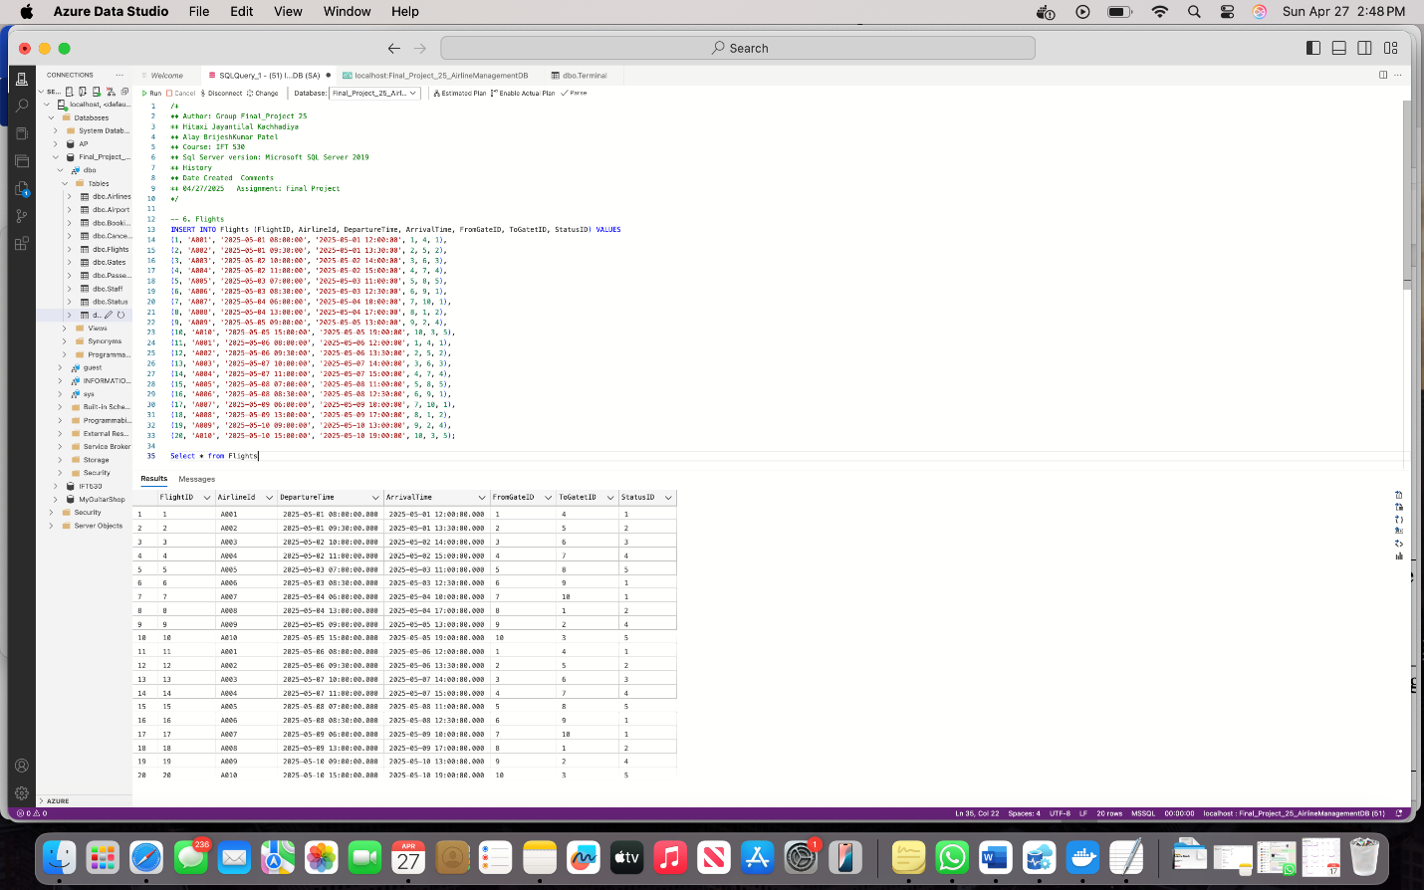

-- 7. Passenger

INSERT INTO Passenger (PassportNumber, FirstName, LastName, Email, Phone) VALUES

('P001', 'Hitaxi', 'Kachhadiya', 'hitaxi@example.com', '1234567890'),

('P002', 'Alay', 'Patel', 'alay@example.com', '2345678901'),

('P003', 'Riya', 'Patel', 'riya@example.com', '3456789012'),

('P004', 'Hasti', 'Lee', 'hasti@example.com', '4567890123'),

('P005', 'Darshit', 'Mangroliya', 'mangroliya@example.com', '5678901234'),

('P006', 'Krutali', 'Thakkar', 'krutali@example.com', '6789012345'),

('P007', 'Samarth', 'Tanaka', 'samarth.t@example.com', '7890123456'),

('P008', 'Shyam', 'Shah', 'shyam@example.com', '8901234567'),

('P009', 'Emily', 'paris', 'emily@example.com', '9012345678'),

('P010', 'shark', 'tank', 'shark@example.com', '0123456789');

Select * from Passenger

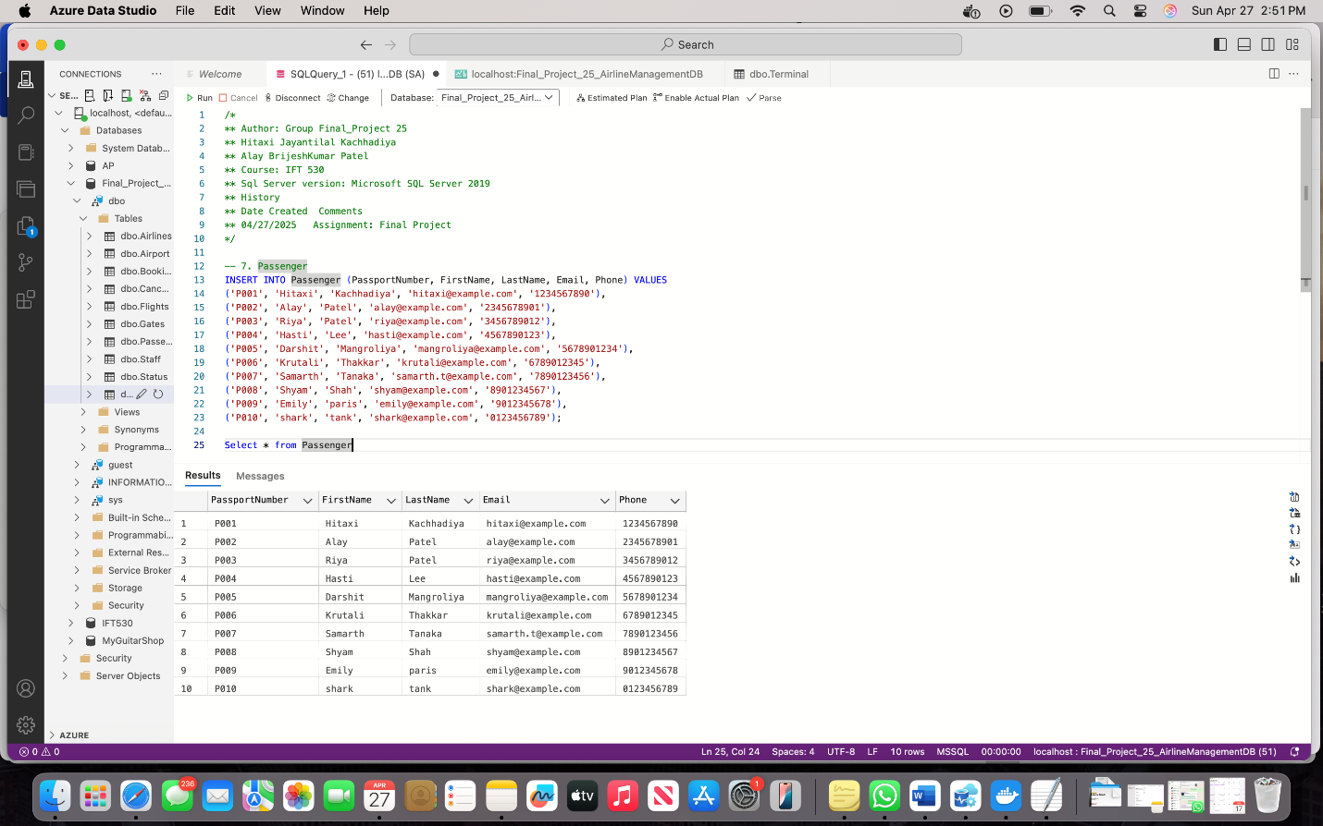

-- 8. Booking

INSERT INTO Booking (BookingID, PassportNumber, FlightID, BookingDate, SeatNumber) VALUES

(1, 'P001', 1, '2025-04-25', '12A'),

(2, 'P002', 2, '2025-04-26', '14B'),

(3, 'P003', 3, '2025-04-27', '15C'),

(4, 'P004', 4, '2025-04-27', '16D'),

(5, 'P005', 5, '2025-04-27', '17E'),

(6, 'P006', 6, '2025-04-28', '18F'),

(7, 'P007', 7, '2025-04-28', '19A'),

(8, 'P008', 8, '2025-04-28', '20B'),

(9, 'P009', 9, '2025-04-28', '21C'),

(10, 'P001', 10, '2025-04-28', '22D'),

(11, 'P002', 11, '2025-04-29', '23E'),

(12, 'P003', 12, '2025-04-29', '24F'),

(13, 'P004', 13, '2025-04-29', '25A'),

(14, 'P004', 14, '2025-04-29', '26B'),

(15, 'P005', 15, '2025-04-29', '27C'),

(16, 'P006', 16, '2025-04-30', '28D'),

(17, 'P007', 17, '2025-04-30', '29E'),

(18, 'P008', 18, '2025-04-30', '30F'),

(19, 'P009', 19, '2025-04-30', '31A'),

(20, 'P010', 20, '2025-04-30', '32B'),

(31, 'P006', 1, '2025-05-03', '43A'),

(32, 'P007', 2, '2025-05-03', '44B'),

(33, 'P008', 3, '2025-05-03', '45C'),

(34, 'P009', 4, '2025-05-03', '46D'),

(35, 'P010', 5, '2025-05-03', '47E');

Select * from Booking

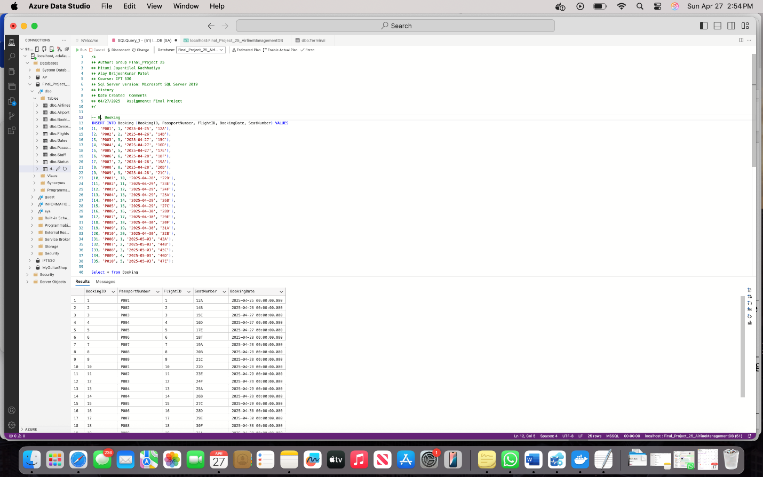

-- 9. Cancellation

INSERT INTO Cancellation (CancellationID, BookingID, CancelledBy, CancellationDate) VALUES

(1, 1, 'Passenger', '2025-04-26'),

(2, 2, 'Staff', '2025-04-26'),

(3, 3, 'Passenger', '2025-04-27'),

(4, 5, 'Staff', '2025-04-28'),

(5, 6, 'Passenger', '2025-04-28'),

(6, 7, 'Staff', '2025-04-29'),

(7, 8, 'Passenger', '2025-04-29'),

(8, 10, 'Staff', '2025-04-29'),

(9, 11, 'Passenger', '2025-04-30'),

(10, 12, 'Passenger', '2025-04-30'),

(11, 13, 'Staff', '2025-05-01'),

(12, 14, 'Passenger', '2025-05-01'),

(13, 15, 'Passenger', '2025-05-01'),

(14, 16, 'Staff', '2025-05-01'),

(15, 17, 'Passenger', '2025-05-02'),

(16, 18, 'Passenger', '2025-05-02'),

(17, 19, 'Staff', '2025-05-02'),

(18, 20, 'Passenger', '2025-05-02'),

(19, 31, 'Staff', '2025-05-04'),

(20, 32, 'Passenger', '2025-05-04');

Select * from Cancellation

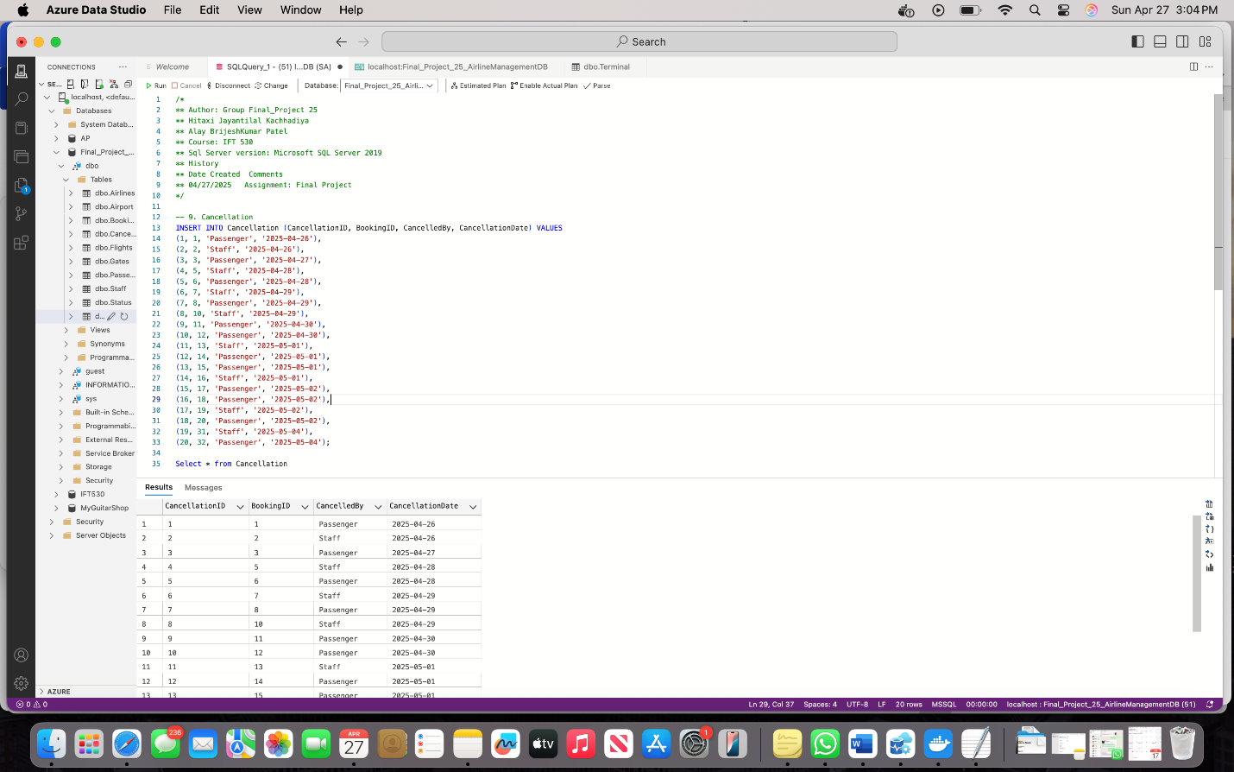

-- 10. Staff

INSERT INTO Staff (StaffID, Name, Role, FlightID) VALUES

(1, 'Jayanti Kachhadiya', 'Pilot', 1),

(2, 'Brijesh Patel', 'Co-Pilot', 1),

(3, 'Dhwani Antala', 'Flight Attendant', 5),

(4, 'Rohit Shah', 'Ground Staff', 6),

(5, 'Dhawal Ghinaiya', 'Security', 8),

(6, 'Mira Sharma', 'Flight Attendant', 9),

(7, 'Mahesh Bajirao', 'Pilot', 10),

(8, 'Amit Kumar', 'Ground Staff', 3),

(9, 'Meet Parmar', 'Co-Pilot', 4),

(10, 'Deep Jala', 'Security', 11);

Select * from Staff

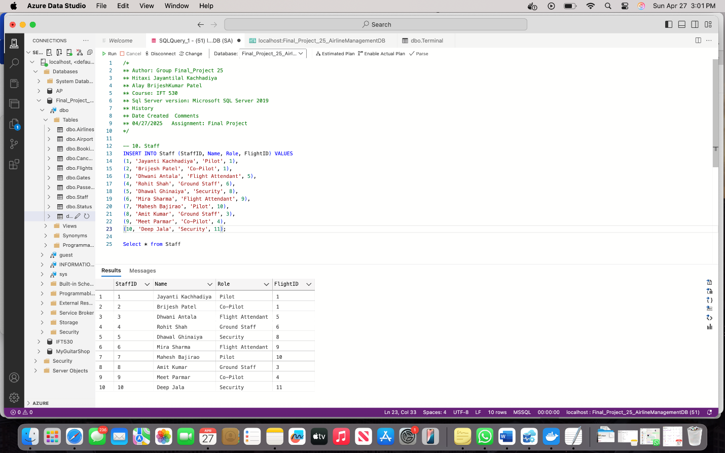

* **Create three queries and convert them into views. Explain why you think would be  
  useful to the user. All queries must be joined to one or more tables. Make sure you restrict the data by using a where clause for each of the queries.**

We created 3 views to make it easier to get useful information: Staff_Assigned_To_Flights, TodayFlights and RecentBookings.

**View 1:**

/*The Airport HR and Operations team can check which staff members are working on each flight, making sure that no flight has too few or too many staff.*/CREATE VIEW Staff_Assigned_To_Flights ASSELECT s.StaffID, s.Name AS StaffName, s.Role, f.FlightID, a.Name AS AirlineName, f.DepartureTimeFROM Staff sINNER JOIN Flights f ON s.FlightID = f.FlightIDINNER JOIN Airlines a ON f.AirlineId = a.AirlineId;

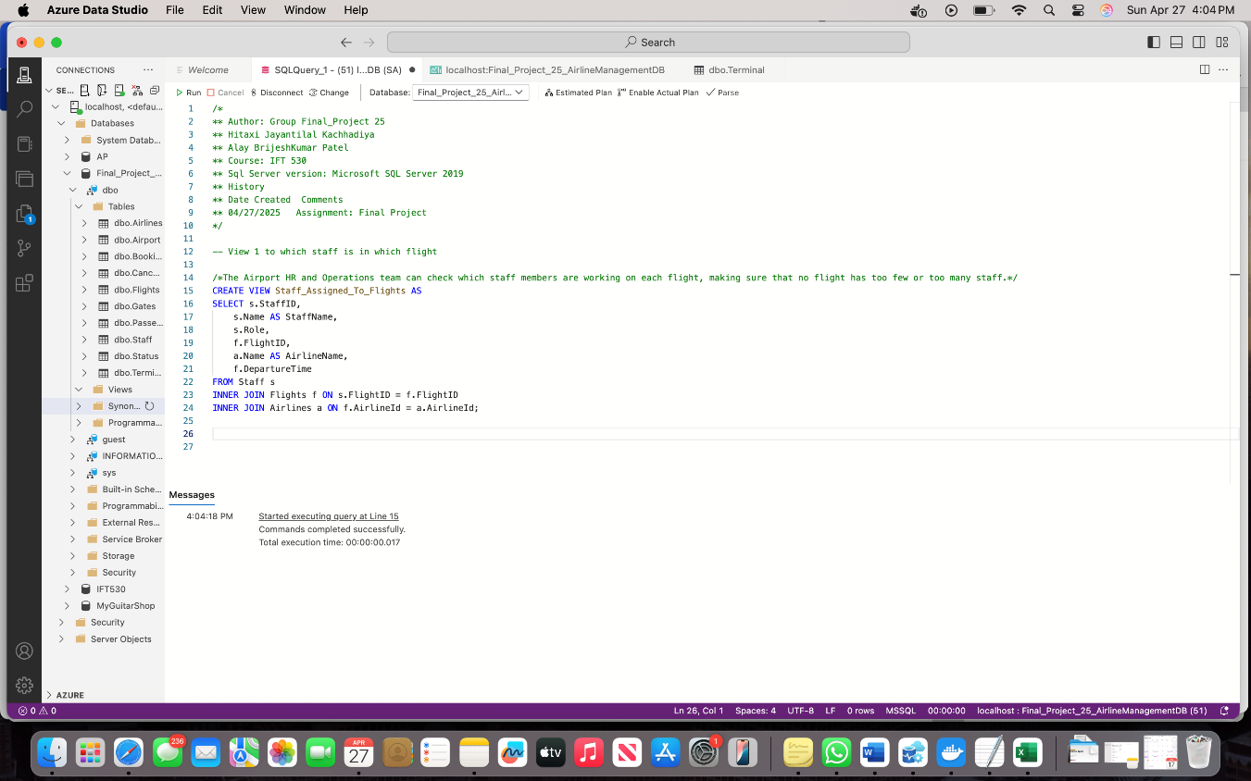

Select * From Staff_Assigned_To_Flights

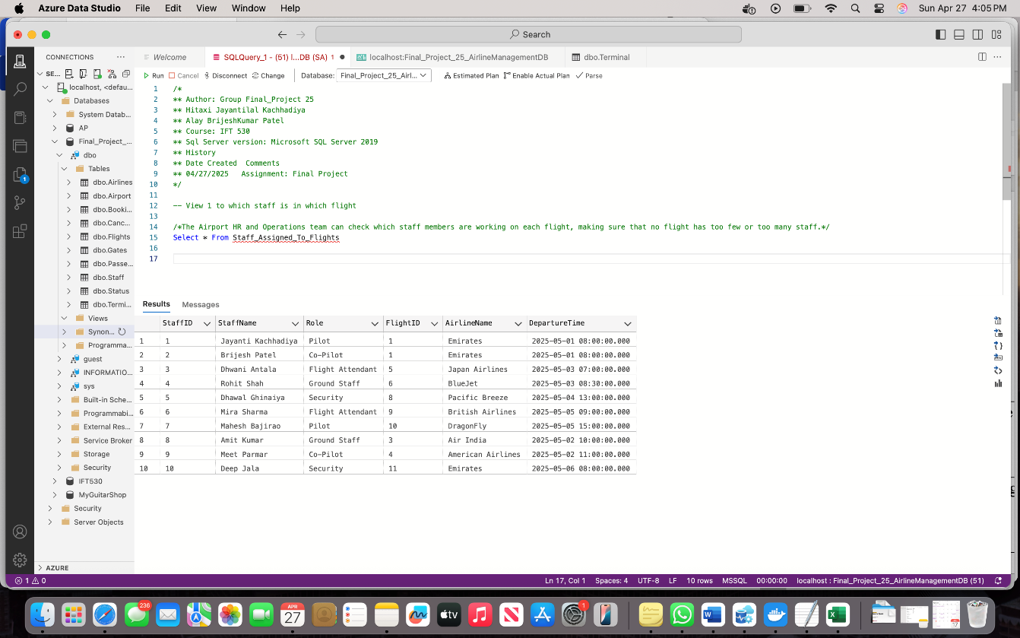

The Airport HR and Operations team can check which staff members are working on each flight, making sure that no flight has too few or too many staff.

**View 2:**

/*It shows all the flights leaving today. This helps terminal managers and airline staff to plan and do their work properly.*/CREATE VIEW TodayFlights ASSELECT a.Name As Airport, t.Name As Terminal, g.GateNumber, f.FlightID, a.Name AS AirlineName, f.DepartureTime FROM Flights fJOIN Airlines a ON f.AirlineId = a.AirlineIdJOIN Gates g ON f.FromGateID = g.GateIDJOIN Terminal t ON g.TerminalID = t.TerminalIDJoin Airport aa On t.AirportID = aa.AirportIdWHERE CAST(f.DepartureTime AS DATE) = CAST(GETDATE() AS DATE);

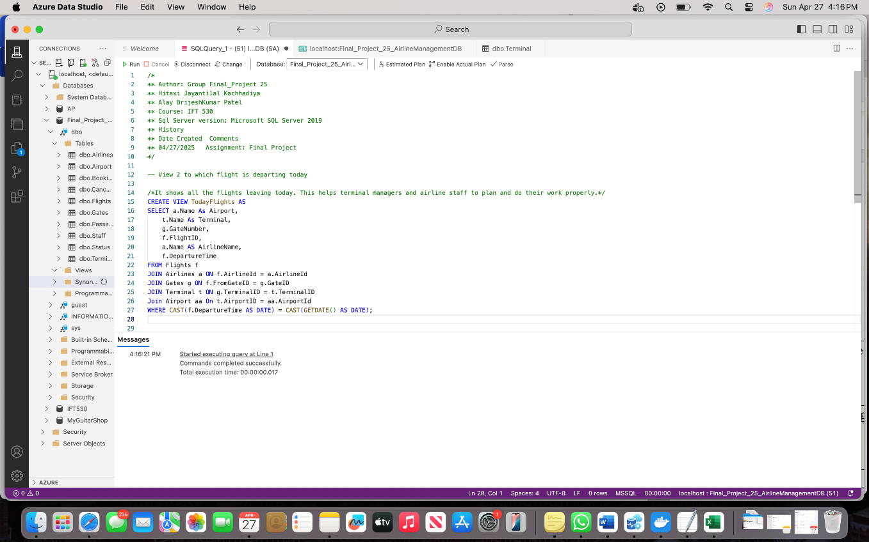

Select * from TodayFlights

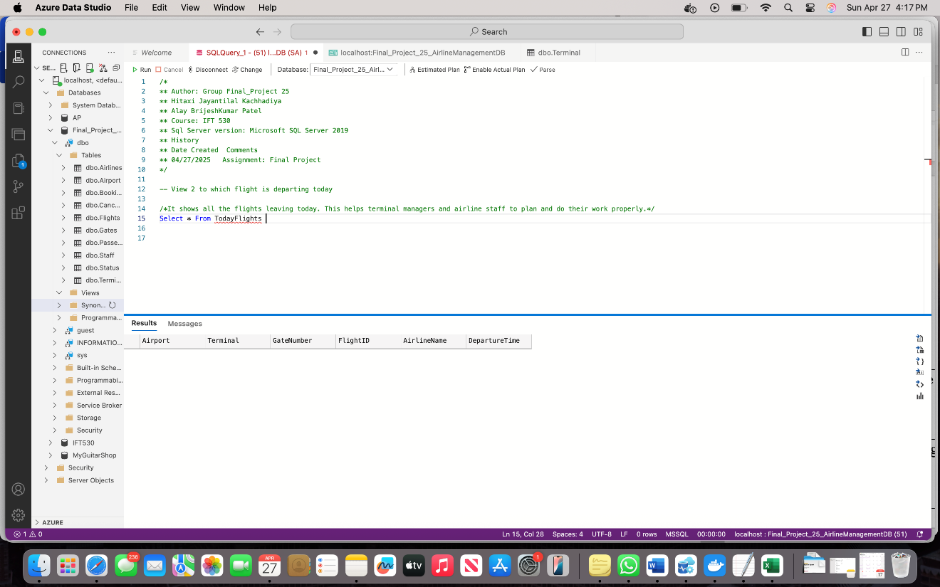

This view shows all the flights leaving today. This helps terminal managers and airline staff to plan and do their work properly.

**View 3:**

/*It helps airlines and their teams see how customers are booking flights lately, so they can plan special offers or rewards for them.*/CREATE VIEW RecentBookings ASSELECT b.BookingID, p.FirstName, p.LastName, f.FlightID, b.SeatNumber, b.BookingDateFROM Booking bJOIN Passenger p ON b.PassportNumber = p.PassportNumberJOIN Flights f ON b.FlightID = f.FlightIDWHERE b.BookingDate >= DATEADD(DAY, -7, GETDATE());

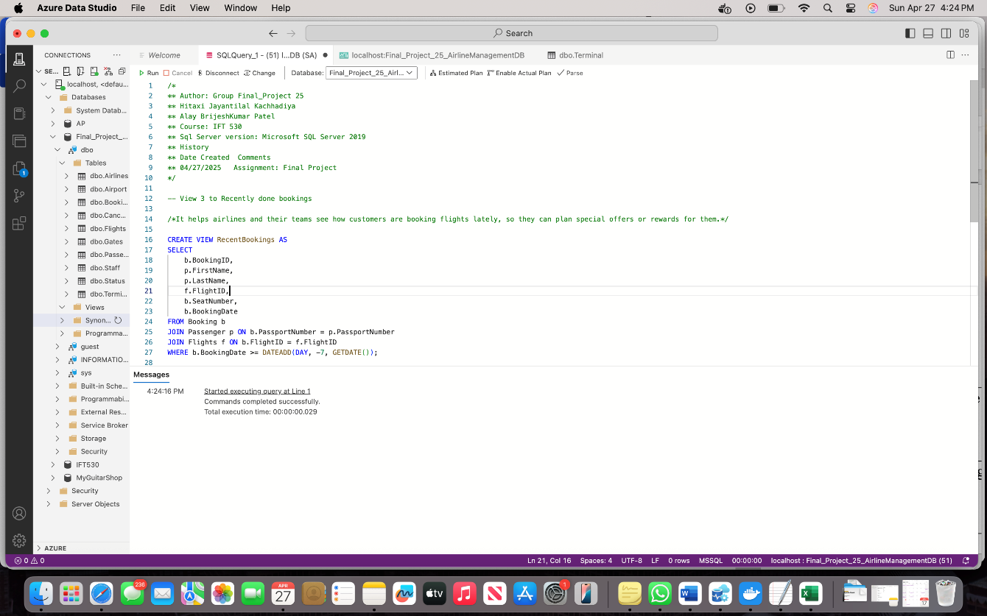

Select * From RecentBookings

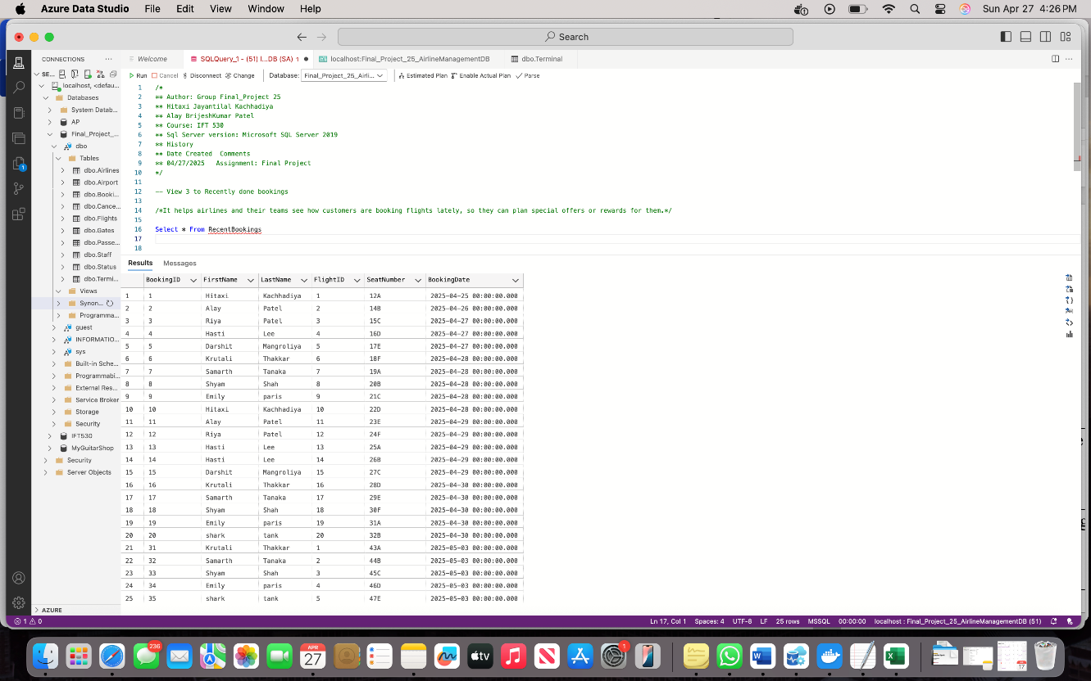

It helps airlines and their teams see how customers are booking flights lately, so they can plan special offers or rewards for them.

* **Create an audit table for one of the lookup tables and demonstrate data saved to that audit table when data in the original table is inserted, modified, or deleted. Include an additional column in the audit table that will have a datetime field when the data was changed in the original table. Include the script to test all the operations**

We made an audit system for the Airlines table. It keeps track of any changes like adding, editing, or deleting a record. This is done using triggers and is saved with the time of the change.

-- Creating Audit table for Airlines

CREATE TABLE AuditAirlines (

AuditID INT IDENTITY(1,1) PRIMARY KEY,

AirlineId VARCHAR(100),

Name VARCHAR(100),

Country VARCHAR(100),

OperationType VARCHAR(10),

OperationDateTime DATETIME DEFAULT GETDATE()

);

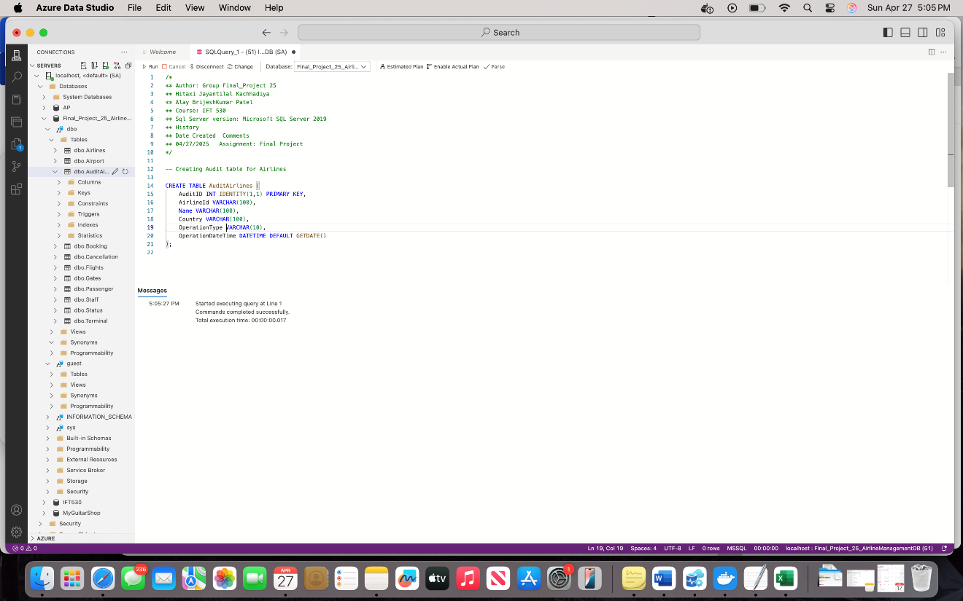

-- Creating Trigger for Entry in AuditAirlines Table when any airline Insert in Table

CREATE TRIGGER InsertAirlineAudit

ON Airlines

AFTER INSERT

AS

BEGIN

INSERT INTO AuditAirlines (AirlineId, Name, Country, OperationType, OperationDateTime)

SELECT AirlineId, Name, Country, 'INSERT', GETDATE()

FROM inserted;

END;

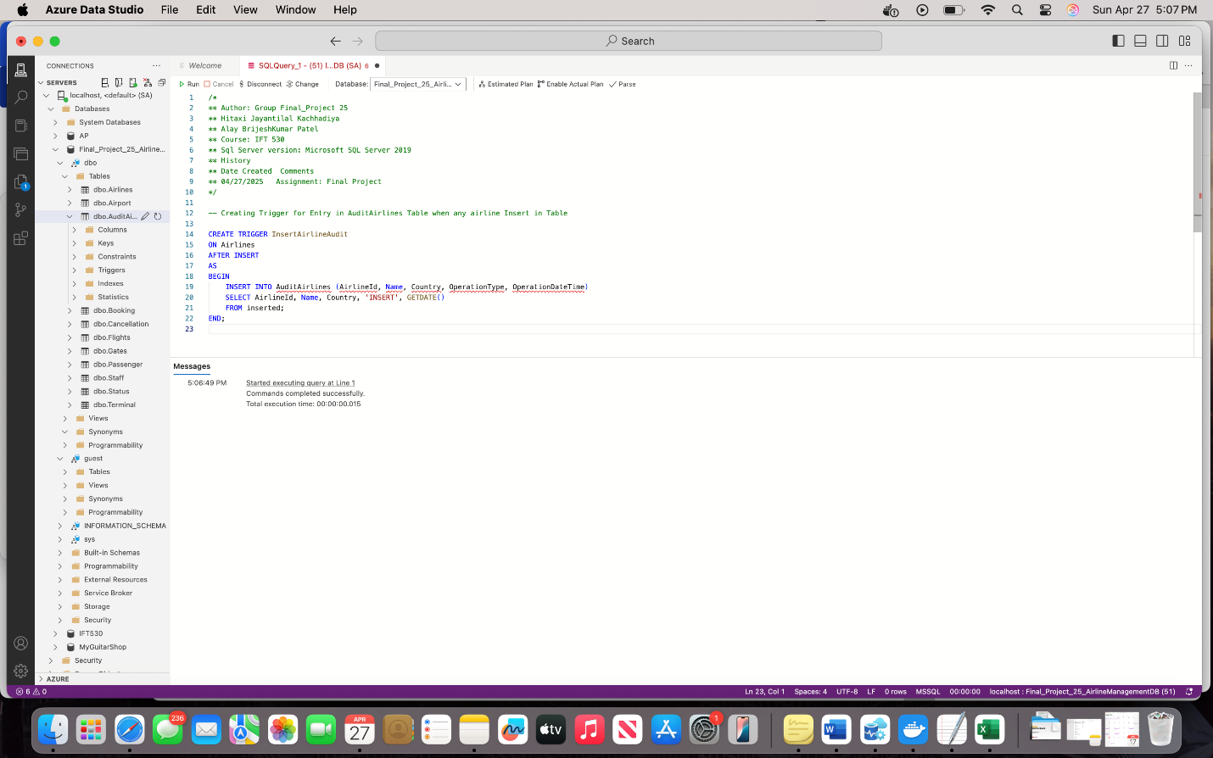

-- Creating Trigger for Entry in AuditAirlines Table when any airline Update in Table

CREATE TRIGGER UpdateAirlineAudit

ON Airlines

AFTER UPDATE

AS

BEGIN

INSERT INTO AuditAirlines (AirlineId, Name, Country, OperationType, OperationDateTime)

SELECT AirlineId, Name, Country, 'Update', GETDATE()

FROM inserted;

END;

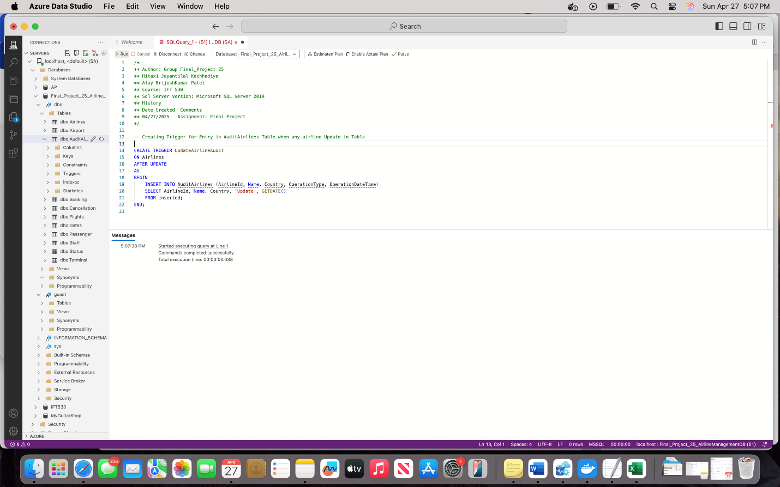

-- Creating Trigger for Entry in AuditAirlines Table when any airline Delete in Table

Create TRIGGER DeleteAirlineAudit

ON Airlines

AFTER DELETE

AS

BEGIN

INSERT INTO AuditAirlines (AirlineId, Name, Country, OperationType, OperationDateTime)

SELECT AirlineId, Name, Country, 'Delete', GETDATE()

FROM deleted;

END;

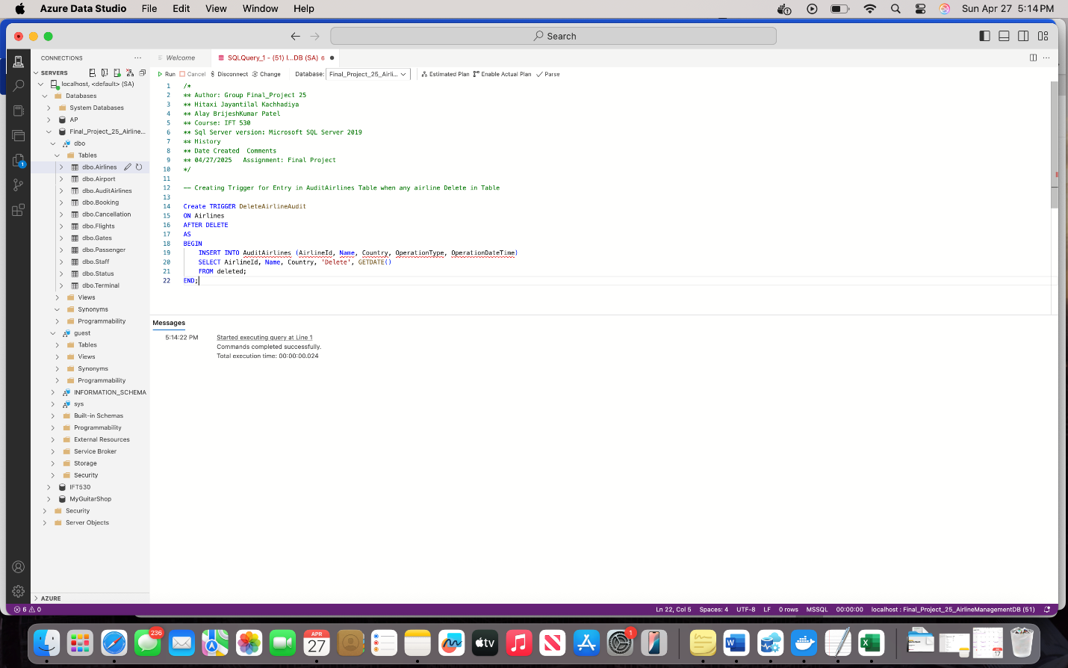

INSERT INTO Airlines (AirlineId, Name, Country)

VALUES ('A012', 'SouthWest', 'USA');

UPDATE Airlines

SET Name = 'SouthWest Airways'

WHERE AirlineId = 'A012';

DELETE FROM Airlines

WHERE AirlineId = 'A012';

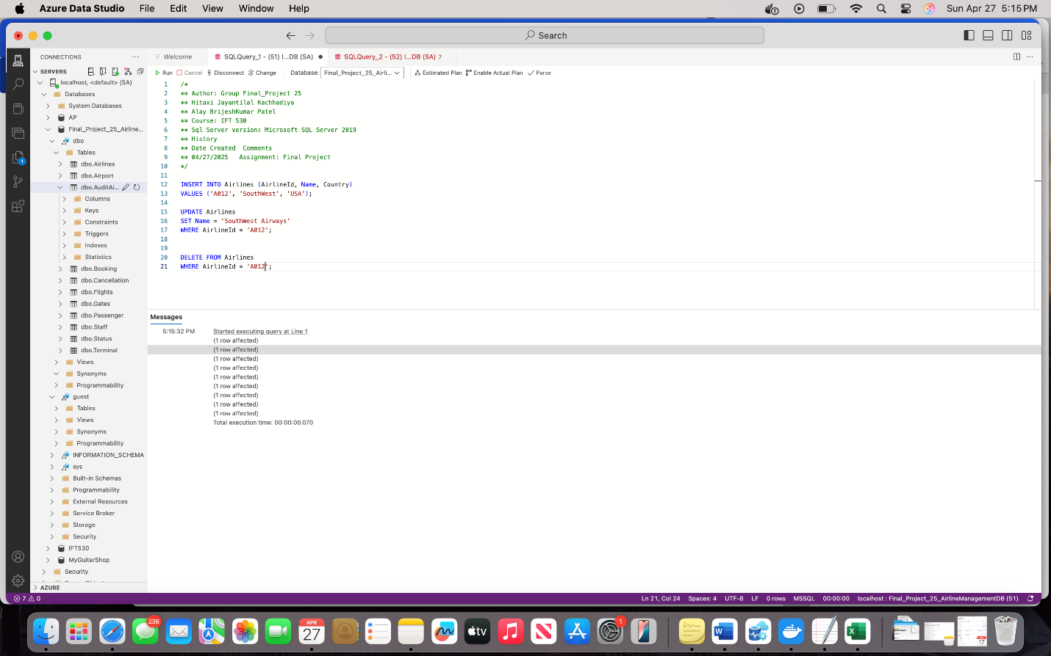

Select * from AuditAirlines

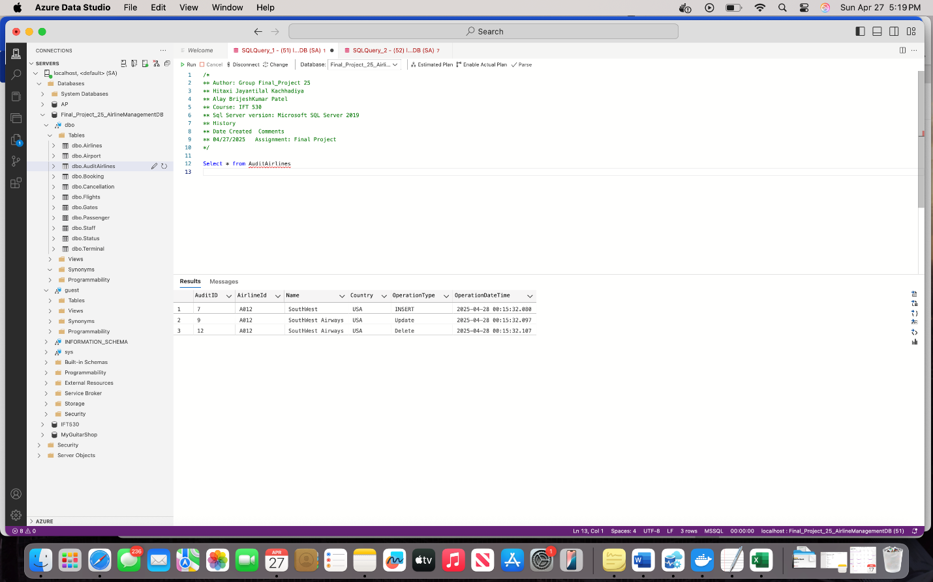

* **Demonstrate a use of the one stored procedures and User Defined Function (UDF) for your database. Include create and drop scripts.**

We made a stored procedure called **GetFlightsByStatus**. It shows flights based on their status like 'Scheduled' or 'Arrived'.

-- Stored Procedure to Get Flights by Status

IF OBJECT_ID('dbo.GetFlightsByStatus') IS NOT NULL

DROP PROCEDURE [dbo].[GetFlightsByStatus];

GO

CREATE PROC GetFlightsByStatus

@StatusNameVar varchar(10) = '%'

AS

BEGIN

SELECT f.FlightID, a.Name, f.DepartureTime, f.ArrivalTime, s.StatusName

FROM Flights f JOIN Status s ON f.StatusID = s.StatusID

JOIN Airlines a ON a.AirlineId = f.AirlineId

WHERE s.StatusName LIKE @StatusNameVar;

END

GO

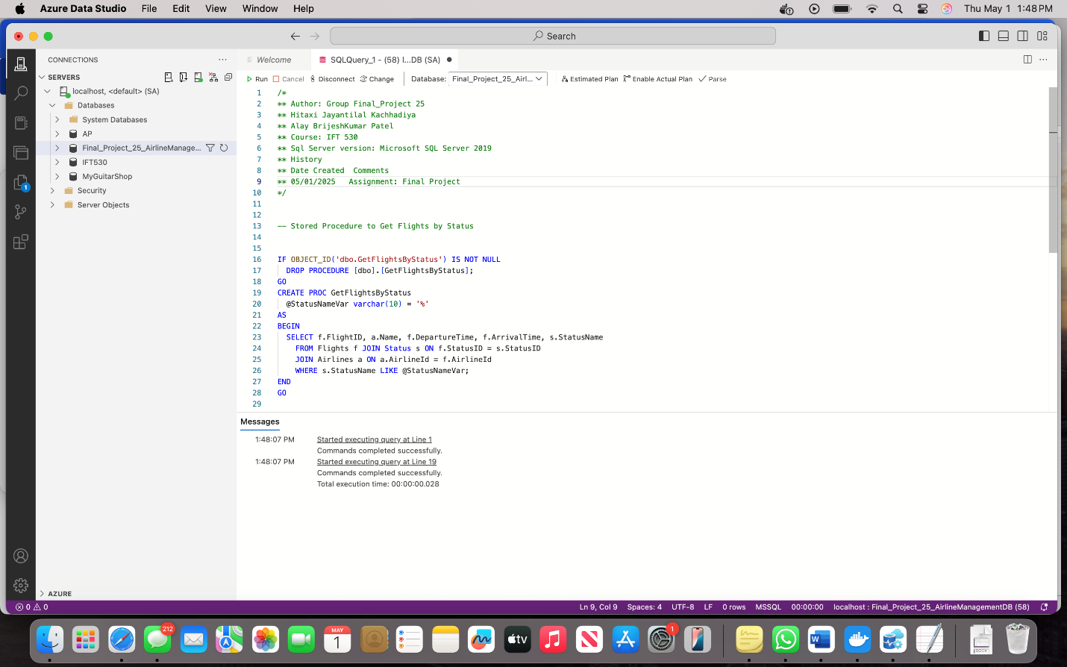

EXEC GetFlightsByStatus 'Arrived'

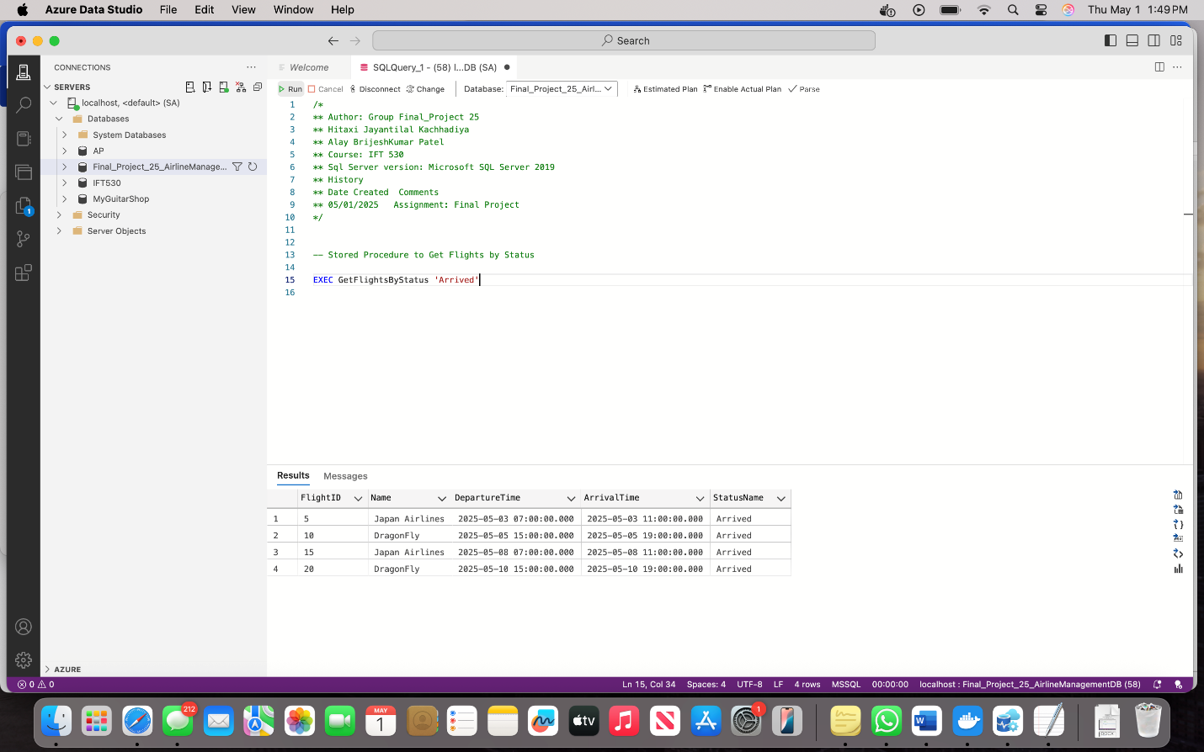

EXEC GetFlightsByStatus

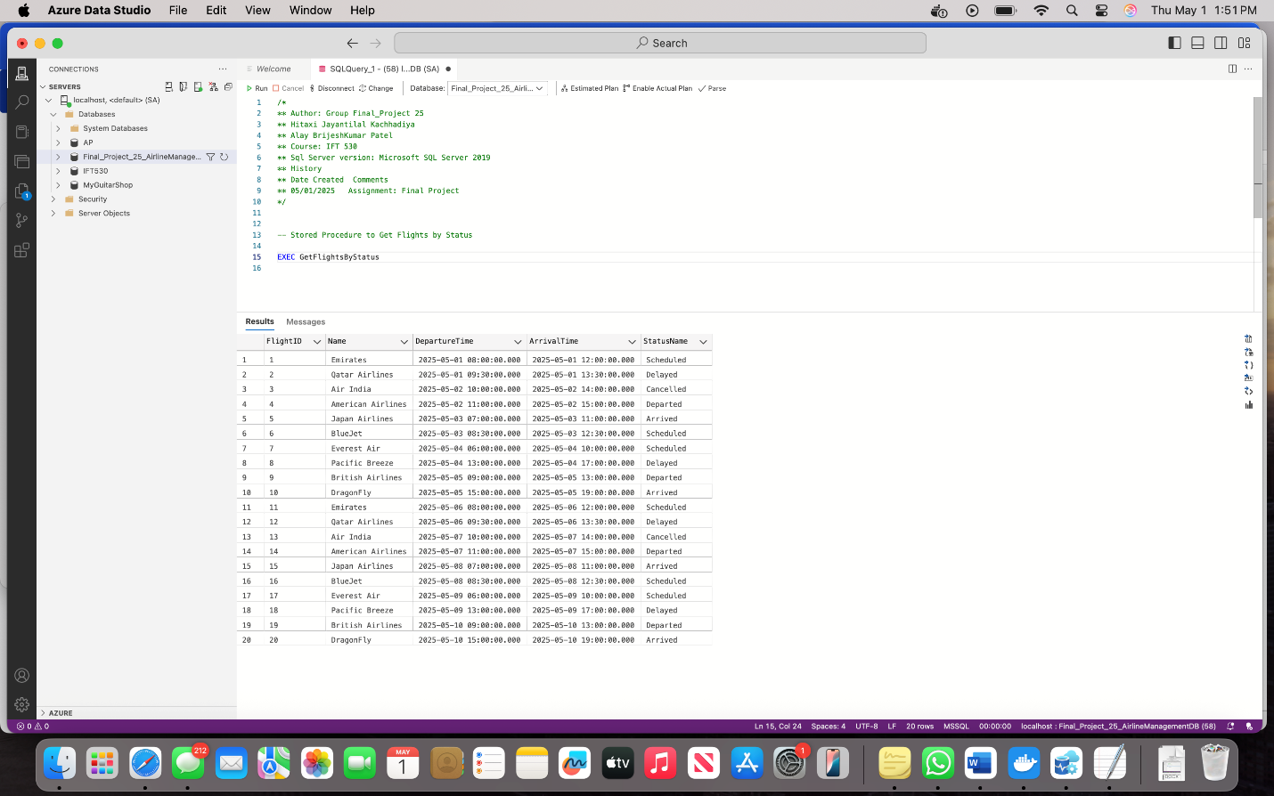

We created a function named fnGetTotalSeatsBooked. It counts how many seats were booked for a specific flight. It makes checking data easier and faster.

-- User Defined Function to calculate total seats booked for a specific flight

IF OBJECT_ID('fnGetTotalSeatsBooked') IS NOT NULL

DROP FUNCTION [dbo].[fnGetTotalSeatsBooked]

GO

CREATE FUNCTION fnGetTotalSeatsBooked(@FlightID INT)

RETURNS int

BEGIN

DECLARE @TotalSeats INT;

SELECT @TotalSeats = COUNT(*)

FROM Booking

WHERE FlightID = @FlightID;

RETURN @TotalSeats;

END;

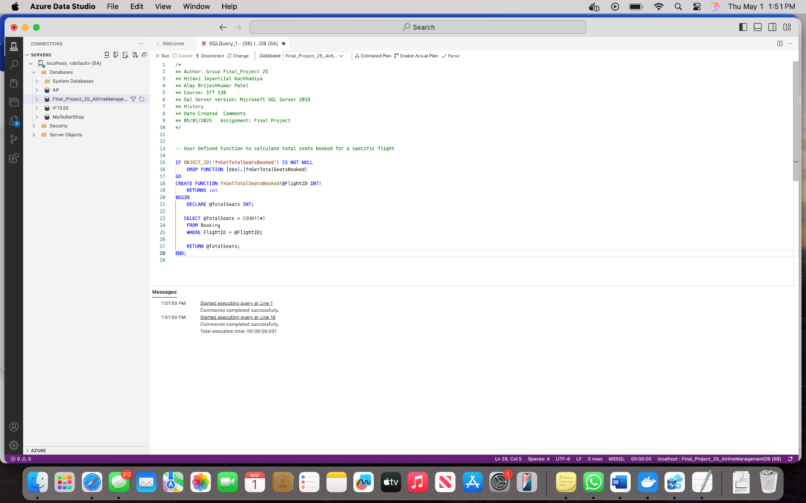

SELECT dbo.fnGetTotalSeatsBooked(1) AS TotalSeatsBookedForFlight1;

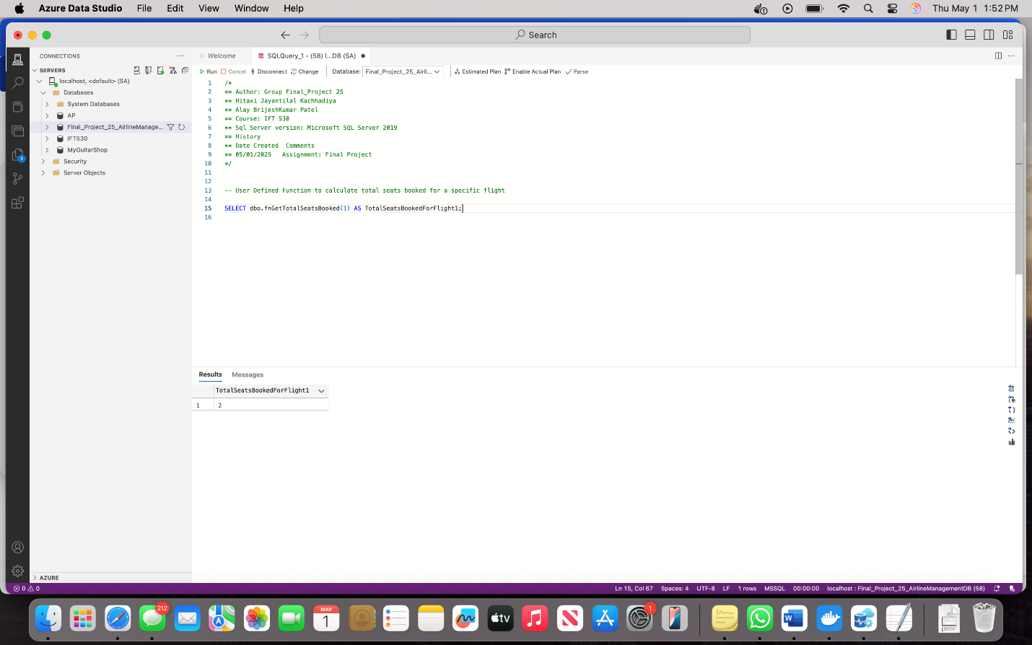

* **Demonstrate the use of one cursor for your database. Create and drop script for cursor.**

We created a cursor to go through all the bookings and print each flight ID, booking ID, and passenger name. It’s useful when we want to handle one row at a time.

-- Create Curser for Flight Id with Passenger Name.DECLARE @FlightID INT;DECLARE @BookingID INT;DECLARE @PassengerName VARCHAR(100);DECLARE FlightCursor CURSOR FORSELECT b.FlightID, b.BookingID, p.FirstName +' '+ p.LastName as PassengerNameFROM Booking b JOIN Passenger p on b.PassportNumber = p.PassportNumberWHERE b.FlightID IS NOT NULL;OPEN FlightCursor;FETCH NEXT FROM FlightCursor INTO @FlightID, @BookingID, @PassengerName;WHILE @@FETCH_STATUS = 0BEGIN PRINT 'FlightID: ' + CAST(@FlightID AS VARCHAR(10)) + ', BookingID: ' + CAST(@BookingID AS VARCHAR(10)) + ', Passenger: ' + @PassengerName; FETCH NEXT FROM FlightCursor INTO @FlightID, @BookingID, @PassengerName;END;CLOSE FlightCursor;DEALLOCATE FlightCursor;

